Installation Guide

jWebSocket
Monitoring resources of computers
Orlando Miranda Gómez

1. Process application download
For the installation of this application should be downloading the packages containing the client and jWebSocket server.
The url address where the application is available for download is http://jwebsocket.org/downloads .
Packages | Size
Monitoring Server | 107,9 Kb
Monitoring Client | 1,4 Mb
2. Installation Process
If where you want to install the application is in the operating system Linux, the package contains the client application must be copied in var/www and to do this you need to install Apache. In addition it should be given all permits through the console. The package contains the server can be stored in any location. Before running the client browser must be set to run the server on an IDE.
If the operating system is Windows should have installed the Wamp application that creates the folder C:\ \wamp\www, this is to copy the package containing the client. The package contains the server can be stored in any location. Before running the client browser must be set to run the server on an IDE.
3. Configuration Options
3.1 Locations of the Sigar´s libraries.
For the full operation of this application is to copy some of the native libraries that have Sigar (System Information Gatherer And Reporter), library that provides data on our computer.
Next described the locations where they should be copied the libraries:
Files | Linux | Solaris | Windows
32 bits | libsigar-x86-linux-1.6.4.so | libsigar-x86-solaris.so | sigar-x86-winnt.dll
64 bits | libsigar-amd64-linux.so | libsigar-amd64-solaris.so | sigar-amd64-winnt.dll
Address | /usr/lib | /usr/lib | c:\program file\java\jdk\bin

This is because Sigar API is a multi-platform cross-language library and command-line tool can access the operating system.
Sigar includes support for Linux, FreeBSD, Windows, Solaris, AIX, HP-UX and Mac OS X through a variety of versions and architectures. API users are given access Sigar laptop inventory and monitoring data, including:
- CPU info.
- Available disk space.
- The amount of space consumed by a specific directory.
- Amount of RAM available and in use.
- Information Network.
- Information about the processes currently running on your system.
- Name and version of operating system.
Url to download the library: http://sourceforge.net/projects/sigar/files/
3.2 Configuration the file emailConf.txt
This file shown in Figure 1.1 to configure the basic data for service by mail. This file should list the parameters in the order listed below:
- Host name. Ej:10.208.0.44
- Port SslSmtp. Ej: 465
- To. Ej: omiranda@hab.uci.cu
- From. Ej: MailNotifier@hab.uci.cu
- Issue. Ej: Warning!!!
- Message. Ej: You have received this warning message,because some of the resources of your machine is in critical condition, check it out.
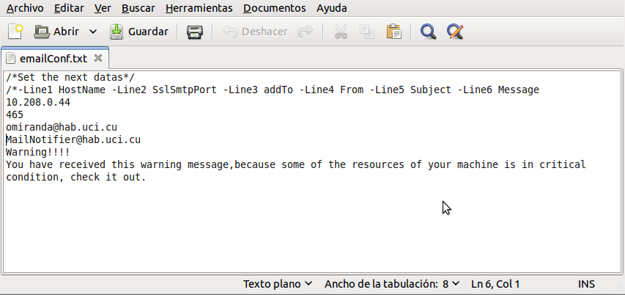
Figure 1.1
4. Putting into operation
To run the application should start the jWebSocket server and then open Monitoring Demo Client at any of the browsers supported by WebSocket.
5. Monitoring Configuration
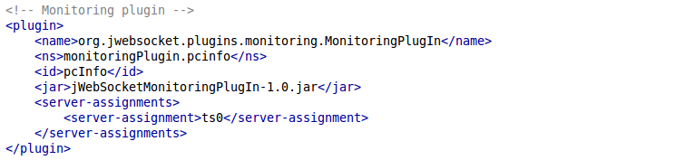
The monitoring plugin settings can be managed in rte/jWebSocket-1.0/conf/jWebSocket.xml, where you can also configure other plugins. Below is the plugin configuration for jWebSocket:
6. Application Management
To management of Monitoring Demo you can be supported in the user manual.
In the event of any problems during installation of the application, contact:
Orlando Miranda Gómez
Mails: omiranda@hab.uci.cu
orlando.miranda86@gmail.com

